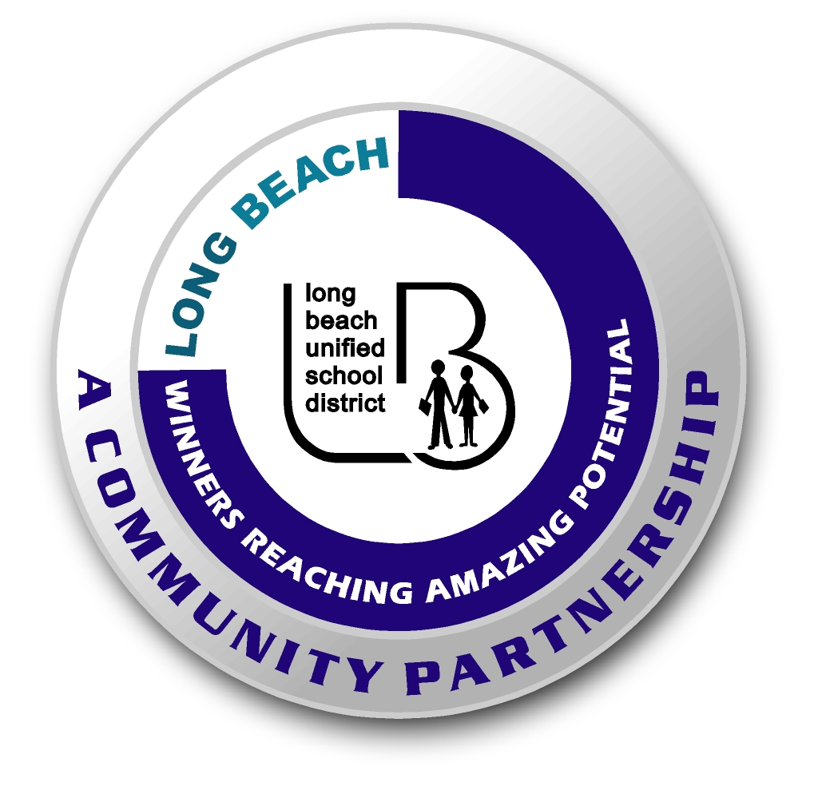
Long Beach WRAP

Lesson Title or Topic: Wings and Flight

Program Leader: _____________________________ Date: __________

Grade Level: 6-8th School Site: __________________________

Materials Needed: (List)
- Top of a one dozen size Styrofoam egg carton.
- Wing template (attached) scissors, penny, pen and white glue

Preparation Time: 5 min Lesson time: 20 min

Content Standard(s) Fun Activity

What will be learned from this activity? (Objective)
- Students will learn how to follow written directions.

Steps of the lesson: (Scientific Method of Investigation)

Introduction: (Questions/Hypothesis):
- This is a fun activity for the class to do. Have them follow the written directions and if they cannot get it to fly have them figure out what they did wrong.

Activity: (Procedure)
- Cut out the wing template (see below), including the hole in the center.
- Place the template on the inside of the upper part of the egg carton lid, with the hole fitting over the center hump. Do NOT cut out the hump! The hole in the template is to allow it to fit over the hump, which will form the cargo bay.
- Place the template inside of the carton top and trace around the template with a pen. Then cut along that line. Note that the wingtips will curve with the lid edges.
- Wedge a penny in the front of the cargo bay (the side without the larger point).
- Use a few drops of white glue to hold the penny in place and wait for it to dry.
- After the glue dries hold your plane by the cargo bay with the penny in front and give it a toss.
Closure: (Conclusions/Results)

- After a few practice throws have a competition for distance or stunts.

  - Modified from Model Aviation Magazine

