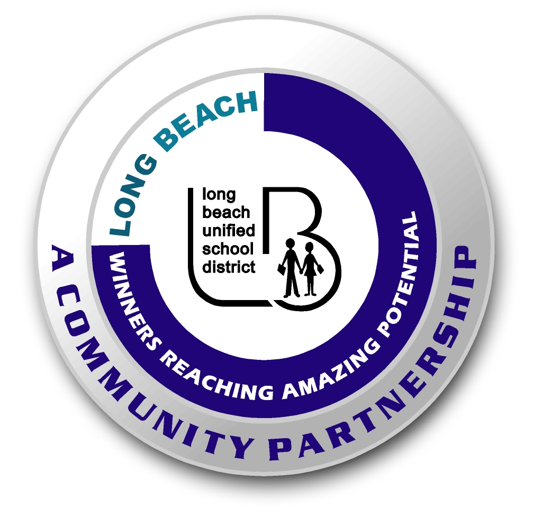
Long Beach WRAP

Lesson Title or Topic: Raisins Dance?

Program Leader: _____________________________ Date: __________

Grade Level: 1st School Site: __________________________

Materials Needed: (List)
- 7 – Up (Regular not diet)
- Clear glass
- Raisins
- Junior size baby food jar with tight-fitting lid
- Class graph for predicting

Preparation Time: 10 min Lesson time: 30 min

Content Standard(s):
Physical Science: Materials come in different forms (states), including solids, liquids, and gases. As a basis for understanding this concept: Students know solids, liquids, and gases have different properties.

Investigation and Experimentation: Students will draw pictures that portray some features of the experiment, record observations and data with pictures, numbers, or written statements, and record observations on a bar graph.

What will be learned from this activity? (Objective)
Students will learn that a substance less dense than water will float.

Steps of the lesson: (Scientific Method of Investigation)
Information: Raisins are denser than water so they sink. The 7 – Up contains bubbles of carbon dioxide which are less dense than water. The bubbles collect on the raisins causing them to float. When they reach the surface, the bubbles pop and the raisins sink to the bottom again. More bubbles form and they “dance” again. The experiment works more quickly if you shake the can first. Be careful when you open the can.

Introduction: (Questions/Hypothesis):
What will happen to the raisins when you mix them with 7 –Up?

Instruction:
1. Show students materials to be used in the experiment and state the problem.
2. Have students choose a hypothesis. Have students complete this sentence frame: The raisins will _______________________. Possible hypotheses: dissolve, sink and explode, dance up and down, float.
3. Chart all student predictions on a class graph.
4. Ask volunteers to explain the reasons for their predictions.
5. Conduct the experiment.

Activity: (Procedure)
- Pour 7 – Up into a clear glass.
- Drop four raisins into the glass.
- Observe what happens.

Closure: (Conclusions/Results)
- What were the results? Discuss the results.
- Have students write: The raisins ____________________. Then they can draw a picture of the experiment.

