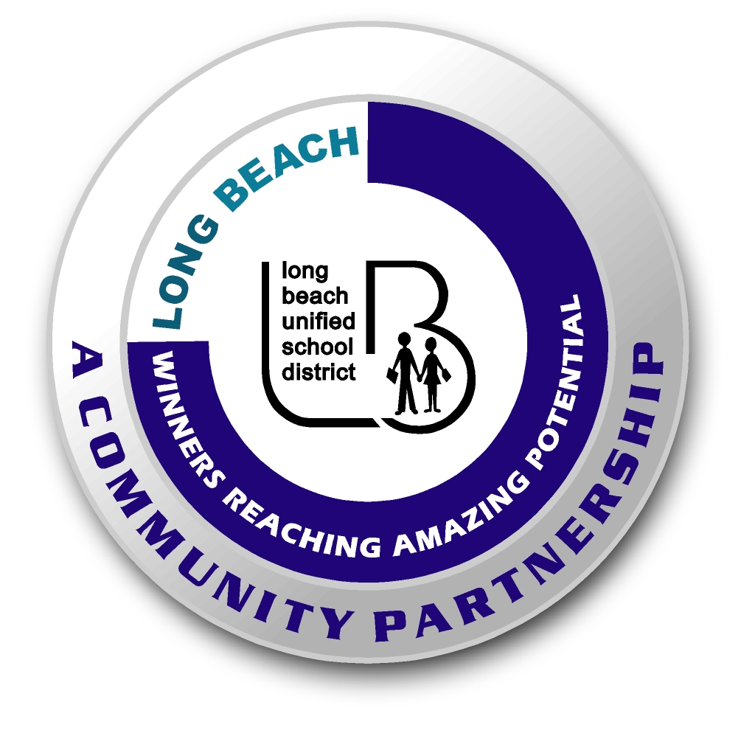
Long Beach WRAP

Lesson Title or Topic: Surface Area and Reaction Time

Program Leader: _____________________________ Date: __________

Grade Level: 6-8th School Site: __________________________

Materials Needed: (List)
- Antacid tablets, two glasses, index cards, watch or clock with second hand

Preparation Time: 5 min Lesson time: 30 min

Content Standard(s) Reactions

What will be learned from this activity? (Objective)
- Students will demonstrate how increasing surface area increases reaction time.

Steps of the lesson: (Scientific Method of Investigation)

Introduction: (Questions/Hypothesis):
- What is surface area?
- Research rocket fuels and propellants.

Instruction:
- Have the student research rocket fuels and propellants.
You can discuss how this relates to the burning of fuel inside of a rocket. Increasing the thrust of a rocket is essential to take off and this can be done by increasing the surface area of its propellants. Solid rocket fuel has a hollow core which allows more of the fuel to burn at a time. Liquid propellants sprayed in a mist accomplish the same because smaller droplets can react faster than larger ones.

Activity: (Procedure)
- Fill the glasses with water (about half full). Make sure the water is the same temperature in both glasses.
- Wrap a tablet in an index card and crush it to a powder.
- Take the crushed tablet and one whole tablet and place them into separate glasses at the same time.
- Time how long it takes for each to dissolve completely.

Closure: (Conclusions/Results)

- Which tablet dissolved the fastest?
- Why did this happen?
- How is this related to rocket propellants?

