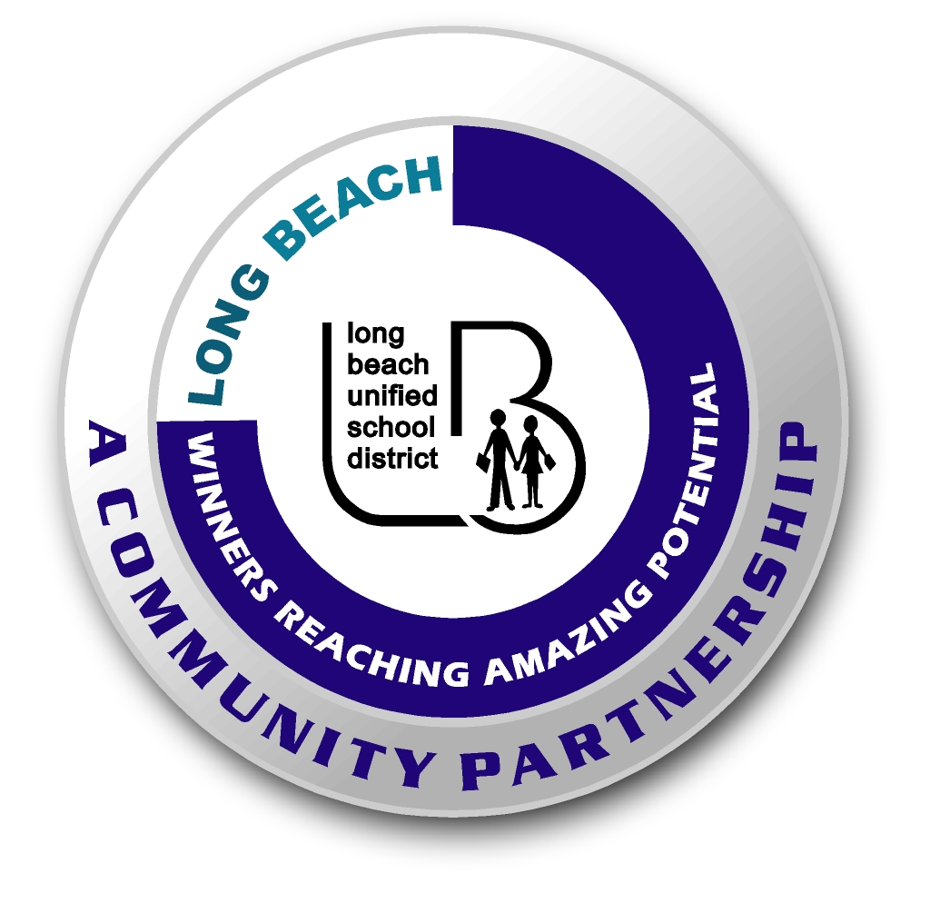
Long Beach WRAP

Lesson Title or Topic: Wavy Water

Program Leader: _____________________________ Date: __________

Grade Level: 1st School Site: __________________________

Materials Needed: (List)
- Jars (Baby food jars, one per child)
- Water
- Vegetable Oil
- Food Coloring
- Class graph for predicting

Preparation Time: 10 min Lesson time: 30 min

Content Standard(s):
Physical Science: Materials come in different forms (states), including solids, liquids, and gases. As a basis for understanding this concept: Students know the properties of substances can change when the substances are mixed, cooled, or heated.

Investigation and Experimentation: Students will draw pictures that portray some features of the experiment, record observations and data with pictures, numbers, or written statements, and record observations on a bar graph.

What will be learned from this activity? (Objective)
Students will learn that liquids of different densities don’t mix.

Steps of the lesson: (Scientific Method of Investigation)
Information: Oil is lighter (less dense) than water and will not mix with it. The water and oil will separate and when gently rocked back and forth will look like a “wave” in the jar.

Introduction: (Questions/Hypothesis):
What happens when water is mixed with oil?

Instruction:
1. Show students materials to be used in the experiment and state the problem.
2. Have students write a hypothesis. Have students complete this sentence frame: The water and oil will _______________________. Possible hypotheses: mix and change color, become cloudy, separate, form a solid.
3. Chart all student predictions on a class graph.
4. Ask volunteers to explain the reasons for their predictions.
5. Conduct the experiment.

Activity: (Procedure)
- Fill a glass jar ¾ full with water.
- Add a few drops of food coloring.
- Mix the water and food coloring.
- Then fill the jar the rest of the way with oil.
- Place the lid on the jar and gently rock the jar.

Closure: (Conclusions/Results)
- What were the results?
- Have students write: The water and oil ____________________. Then they can draw a picture of the experiment.

