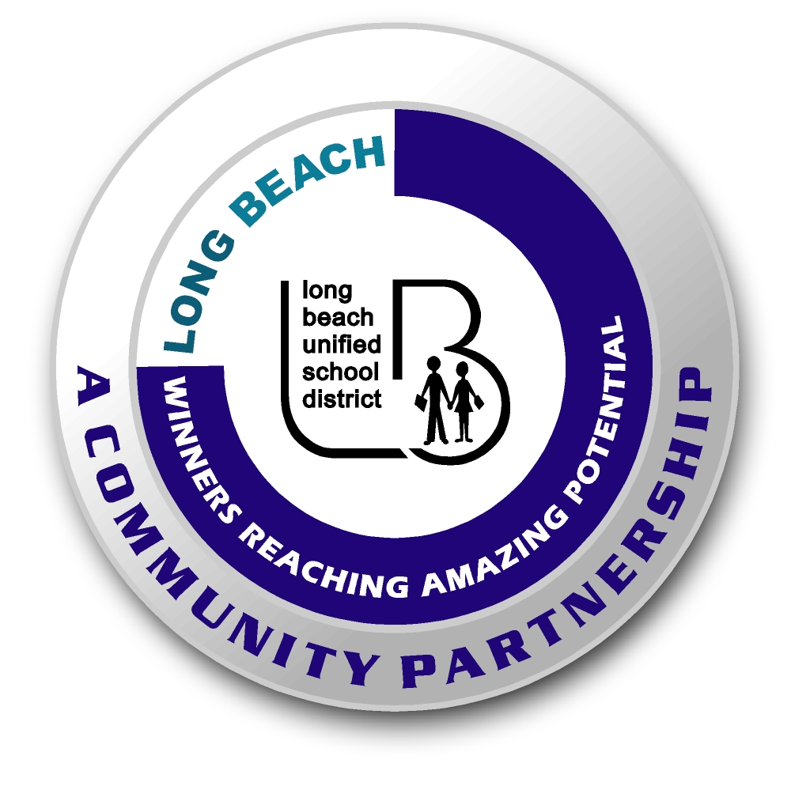
Long Beach WRAP

Lesson Title or Topic: Cool Ice

Program Leader: _____________________________ Date: __________

Grade Level: 1st School Site: __________________________

Materials Needed: (List)
- Two glasses
- Ice cubes
- Salt
- Water
- Thermometer
- Class graph for predicting

Preparation Time: 10 min Lesson time: 30 min

Content Standard(s):
Physical Science: Materials come in different forms (states), including solids, liquids, and gases. As a basis for understanding this concept: Students know the properties of substances can change when the substances are mixed, cooled, or heated.

Investigation and Experimentation: Students will draw pictures that portray some features of the experiment, record observations and data with pictures, numbers, or written statements, and record observations on a bar graph.

What will be learned from this activity? (Objective)
Students will learn that salt affects the freezing point of water.

Steps of the lesson: (Scientific Method of Investigation)
Information: Fresh water freezes at 32 degrees F (at 0 degrees C). When salt is added to the water, the freezing temperature becomes lower than 32 degrees F. An ice cube in salt water will start to melt quickly because the ice cube is now warmer than the salty water.

Introduction: (Questions/Hypothesis):
In which type of water (fresh or salt) will the ice cube melt faster?

Instruction:
1. Show students materials to be used in the experiment and state the problem.
2. Have students write a hypothesis. Have students complete this sentence frame: The ice cubes will _______________________. Possible hypotheses: melt faster in fresh water, melt faster in salt water, melt at the same rate in fresh and salt water, will not melt. Discuss each of these choices so that the students understand.
3. Chart all student predictions on a class graph.
4. Ask volunteers to explain the reasons for their predictions.
5. Conduct the experiment.

Activity: (Procedure)
- Fill one glass with fresh water.
- Fill the other glass with salt water. Make sure you put the same amount of water in each glass.
- Put an ice cube in each glass along with a thermometer.
- Record what is happening with the ice cube and the temperature of the water.

Closure: (Conclusions/Results)
- What were the results? Which ice cube melted faster?
- Have students write: The ice cube ____________________. Then they can draw a picture of the experiment.

