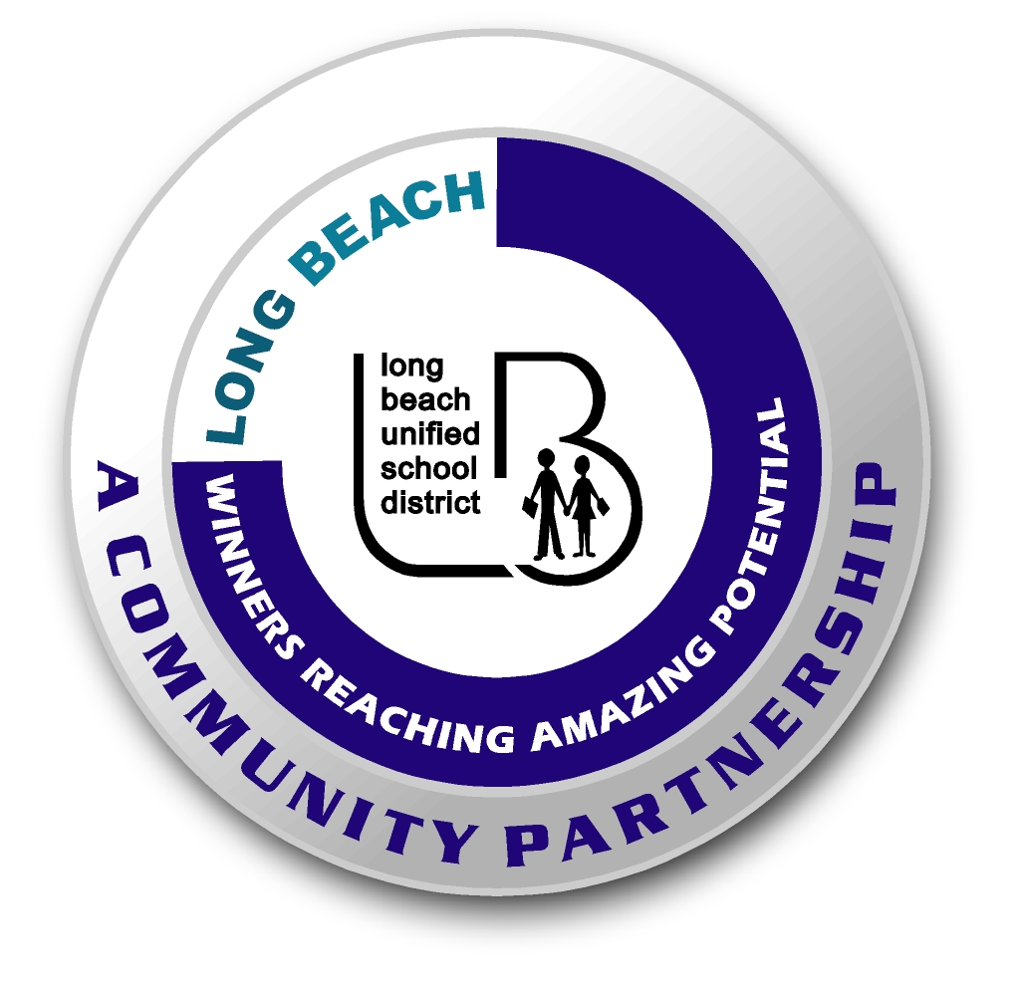
Long Beach WRAP

Lesson Title or Topic:

How does salt affect the way things float in water?

Program Leader: _____________________________ Date: __________

Grade Level: 3rd School Site: __________________________

Materials Needed: (List)
- 2 Mixing Bowls
- measuring cup and water
- spoon
- sea salt
- one fresh egg

Preparation Time: 10 min Lesson time: 30 min

Content Standard(s) Collect data in an investigation to develop a logical conclusion

What will be learned from this activity? (Objective)
- Students will learn how salt affects the way things float in water.

Steps of the lesson: (Scientific Method of Investigation)

Introduction: (Questions/Hypothesis):
- Does salt water affect the way things move or float? Form a hypothesis.

Instruction:
Animals that live in the Earth’s oceans move around easily. Is this an adaptation of the sea creatures or a result of the salt water?

Activity: (Procedure)
- Label one bowl fresh water and the other bowl salt water. Pour 400ml of water into each bowl.
- Pour 1/8 cup of sea salt into the bowl labeled salt water and stir.
- Carefully place a fresh egg in the fresh water bowl. Record what happens in a chart.
- Have the group report to the class their results.
- Take the egg out and gently place it in the salt water bowl. Record what you observe in the chart.

Closure: (Conclusions/Results)
- What were the results?
- Does the egg float in fresh water? In salt water?
- Have students come to a conclusion, and infer- how does salt affect the way animals move in the oceans?
- Explain their inference in a paragraph.

